**Question 1: You are setting up a virtualized environment using Hyper-V. Describe how you would create and configure a new virtual machine.**

Answer:

* **Enable Hyper-V:**

1. Ensure that our system supports virtualization (check BIOS/UEFI settings and enable Intel VT-x or AMD-V if necessary).
2. Enable Hyper-V on our Windows system (Windows 10 Pro, Enterprise, or Education):
   * Go to "Control Panel" > "Programs" > "Turn Windows features on or off".
   * Check the "Hyper-V" option and click "OK".
   * Restart our computer if prompted.

# Creating a New Virtual Machine

1. **Open Hyper-V Manager:**

* Press Windows Key + X and select "Hyper-V Manager".
* Alternatively, search for "Hyper-V Manager" in the Start menu.

1. **Create a New Virtual Machine:**

* In Hyper-V Manager, right-click on our host machine name in the left pane.
* Select "New" > "Virtual Machine".

1. **Specify Name and Location:**

* Enter a name for our VM(e.g. myVM).
* Choose a different location to store the VM files by checking "Store the virtual machine in a different location" and specifying the path.

1. **Specify Generation:**

* Select the VM generation. Typically, Generation 1 is for legacy operating systems, and Generation 2 is for newer ones with UEFI-based firmware.

1. **Assign Memory:**

* Specify the amount of RAM for the VM. Ensure that you allocate enough memory based on the requirements of the guest OS and applications.
* Enable Dynamic Memory if you want the VM to use memory more efficiently.

1. **Configure Networking:**

* Select a virtual switch to connect the VM to the network. If you haven't created one, you can do so by opening the "Virtual Switch Manager" from the right-hand pane in Hyper-V Manager and creating a new virtual switch.

1. **Connect Virtual Hard Disk:**

* Create a new virtual hard disk. Specify the name, location, and size of the disk.
* Use an existing virtual hard disk or attach a virtual hard disk later.

1. **Install Operating System:**

* Choose whether to install an operating system later, install an OS from a bootable image file (ISO), or install an OS from a bootable CD/DVD-ROM.
* If you select the ISO option, browse to the location of our ISO file.

1. **Complete the Wizard:**

* Review our settings and click "Finish" to create the VM.

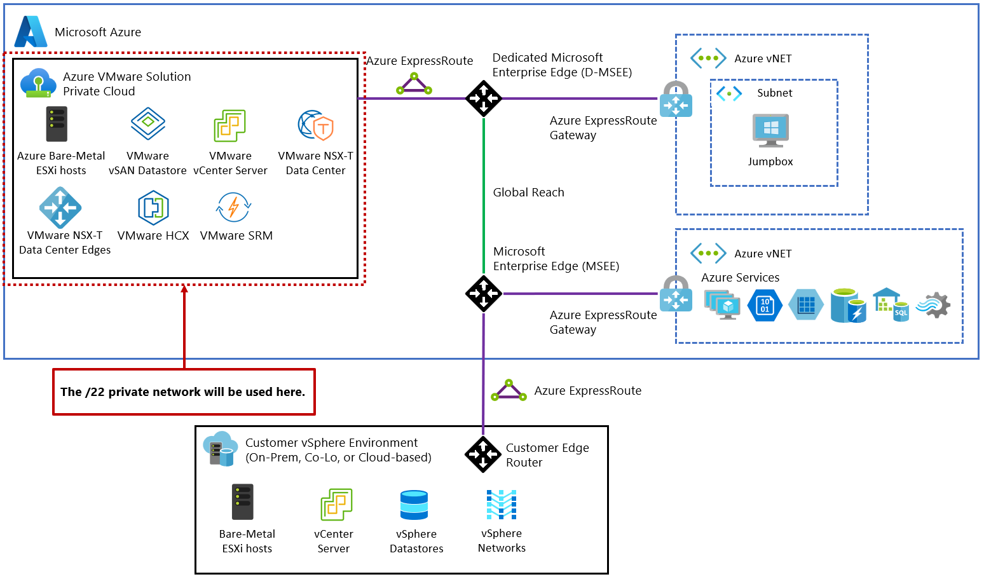

# Configuring the Virtual Machine

1. **Adjust VM Settings:**

* Right-click on the newly created VM in Hyper-V Manager and select "Settings".
* Adjust settings as needed:
  + Processor: Increase the number of virtual processors.
  + Memory: Adjust the startup and maximum RAM.
  + Hard Drive: Add additional virtual hard disks if needed.
  + Network Adapter: Configure advanced features such as MAC address or VLAN ID.
  + Integration Services: Enable/disable services like guest shutdown, time synchronization, and data exchange.

1. **Start the VM:**

* Right-click the VM and select "Connect".
* Click "Start" to boot the VM.

1. **Install the Operating System:**

* Follow the installation process of the guest OS. If you chose to install from an ISO, the VM should boot from it and begin the OS installation.

1. **Install Integration Services (if applicable):**

* For some guest operating systems, you may need to install Hyper-V Integration Services to enhance performance and integration with the host.

## Post-Installation Configuration

1. **Update the Guest OS:**

* Ensure the guest OS is updated with the latest patches and drivers.

1. **Install Necessary Software:**

* Install any required applications or tools on the guest OS.

1. **Configure Backup and Snapshot:**

* Configure backup settings for our VM.
* Use Hyper-V Manager to create snapshots for quick recovery points.